
Saskatchewan Polytechnic
Md Alamgir Hossain
Business Information Systems (BIS) Saskatchewan Polytechnic
PowerShell Manual

Table of Contents
CHAPTER | 01 1
PowerShell: 1
What is Windows PowerShell 1
What does it do? 1
How To run PowerShell in your windows Desktop: 2
1. Get-Clipboard 3
1.2 What does the command do? 3
1.3 Key Functionality and Parameters Get-Clipboard 3
1.4 Example of Get-Clipboard cmdlet: 4
1.4.1. Get-Clipboard -raw 4
1.4.3. Get-Clipboard -Format Text 4
2.The Clear-RecycleBin cmdlet 5
2.1 What does the command do? 5
2.2 Key Functionality and Parameters Clear-RecycleBin 5
2.3 Example of Clear-RecycleBin cmdlet: 6
2.3.1 Clear-RecycleBin without force parameter. 6
2.3.2. Clear-RecycleBin with force parameter 6
3. New-LocalUser 7
3.1 What does the command do? 7
3.2 Key Functionality and Parameters New-LocalUser 7
3.3 Example of New-LocalUser 8
3.3.1 Create a User Account Without a Password 8
3.3.2 Create a User Account with a expire date 8
4. Set-LocalUser cmdlet 9
4.1 What does the command do? 9
4.2 Key Parameters of Set-LocalUser 9
4.3 Example of Set-LocalUser cmdlet 10
4.3.1 Change a User's Description 10
4.3.2 Set an Existing User's Password 10

CHAPTER | 02 11
PowerShell Script File to open three news websites in separate tabs. 11
1. What is PowerShell Script File? 11
2. What PowerShell Script File does 11
3. How to create a ps1 file: 11
3.1 Step 1: Open a Text Editor 11
3.2 Step 2: Enter the Script Content 11
3.3 PowerShell Code for Script File 12
3.4 Step 3: Save the File 12
4. How to run the PowerShell Script 12
4.1 Option 1: Run from PowerShell (Recommended) 12
4.2 Option 2: Run by Double-Clicking (Requires Setup) 13
References 1

List of Figures
Figure 1: Windows PowerShell 1
Figure 2: Step1: Open PowerShell 2
Figure 3: Step2: Open PowerShell 2
Figure 4: PowerShell Windows run as administrator 2
Figure 5:Get-Clipboard with -Raw 4
Figure 6: Get-Clipboard with format text 4
Figure 7: Clear-RecycleBin 6
Figure 8: Clear-RecycleBin -force 6
Figure 9: New-LocalUser cmdlet 8
Figure 10: New-LocalUser with Expire Parameter 8
Figure 11: Set-LocalUser cmdlet 10
Figure 12: Set-LocalUser 10
Figure 13: TodaysNews.ps1 12
Figure 14:Run PowerShell (right-click) 13
Figure 15: Windows with three news sites 13
Figure 16: Set-ExecutionPolicy 13

List of Tables
Table 1: Get-Clipboard Parameters 3
Table 2:Clear-RecycleBin cmdlet Parameters 5
Table 3: New-LocalUser Parameters 7
Table 4: Set-LocalUser cmdlet parameters 9

CHAPTER | 01

PowerShell:
PowerShell is a cross-platform task automation solution made up of a command-line shell, a scripting language, and a configuration management framework. PowerShell runs on Windows, Linux, and macOS (MicroSoft, 2025).

What is Windows PowerShell
Windows PowerShell is the version of PowerShell that ships in Windows. This version of PowerShell uses the full .NET Framework, which only runs on Windows. The latest version is Windows PowerShell 5.1. Microsoft is no longer updating Windows PowerShell with new features. Support for Windows PowerShell is tied to the version of Windows you are using (MicroSoft, 2025).
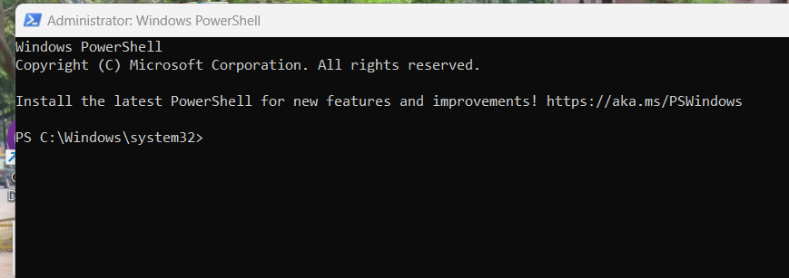


Figure 1: Windows PowerShell

What does it do?
PowerShell is very powerful tools used in cross-platform task automation and configuration management framework developed by Microsoft. It combines a command-line shell with a scripting language built on the .NET Common Language Runtime (CLR) (Microsoft, 2025).
It is usually used by system administrators, DevOps professionals, and developers to automate, manage, and configure computer systems and applications to make their task more time saving and convenient. (Microsoft, 2025)

How To run PowerShell in your windows Desktop:
Step 1: Go to your search windows search option located and type Windows PowerShell.
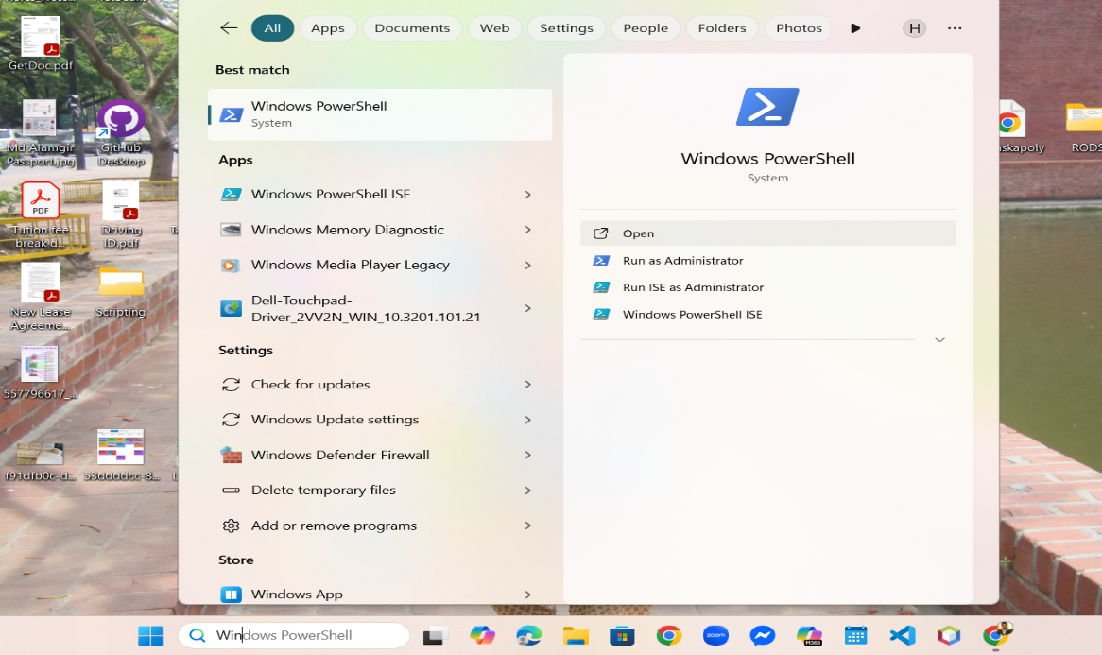
Figure 2: Step1: Open PowerShell

Step 2: Your will find a selection menu popped up in your computer. Run Windows PowerShell as Administrator.
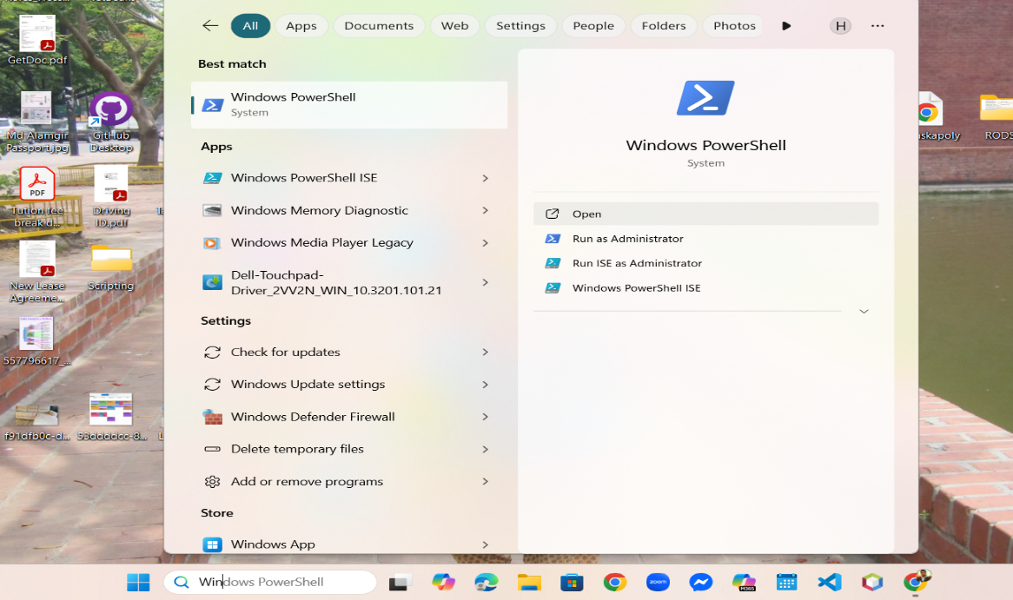
Figure 3: Step2: Open PowerShell

Step 3: Now, user is in Windows PowerShell. Please confirm if you run the windows as Administrator, you will see the windows below:
Figure 4: PowerShell Windows run as administrator

1. Get-Clipboard
The Get-Clipboard cmdlet gets the contents of the clipboard as text. Multiple lines of text are returned as an array of strings similar to Get-Content.

1.2 What does the command do?
The Get-Clipboard cmdlet in PowerShell retrieves the contents of the system clipboard. It can return data as text, a list of files, or an image, and you can use the -Format parameter to specify the data type you want. (Microsoft, 2025)

1.3 Key Functionality and Parameters Get-Clipboard
Parameter | Purpose | Applicable PowerShell Version
(Default) | Retrieves the clipboard content as a string or an array of strings (if it contains multiple lines). | All
-Raw | Retrieves the entire clipboard content as a single, multiline string, ignoring newline character formatting. | All
-Format FileDropList | Retrieves information about any files or folders that have been copied (like in File Explorer). This returns a collection of FileInfo or DirectoryInfo objects. | Windows PowerShell (v5.1 and earlier) Only
-Format Image | Retrieves the copied data as an Image object (useful for saving screenshots or copied images to a file). | Windows PowerShell (v5.1 and earlier) Only
(Microsoft, 2025)
Table 1: Get-Clipboard Parameters

1.4 Example of Get-Clipboard cmdlet:

1.4.1. Get-Clipboard -raw
PowerShell Code:
Get-Clipboard -Raw
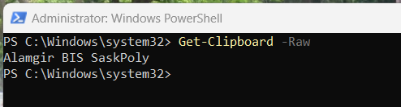
Figure 5:Get-Clipboard with -Raw

Explanation:
Here Get-Clipboard cmdlet -Raw parameter is used to get multiline text as a single, large string instead of an array.

1.4.3. Get-Clipboard -Format Text
PowerShell Code
Get-Clipboard -format Text
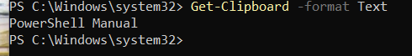
Figure 6: Get-Clipboard with format text

Explanation:
This command retrieves the text contents from the clipboard. The -Format parameter specifies that we want to get the clipboard contents specifically in text format.

2.The Clear-RecycleBin cmdlet
The Clear-RecycleBin cmdlet deletes the content of the current user's recycle bin. This action is like using Windows Empty Recycle Bin.

2.1 What does the command do?
It clears the RecycleBin from local computer or remote server. The Clear-RecycleBin cmdlet in PowerShell is used to permanently delete the content of the current user's Recycle Bin. This action is the equivalent of right-clicking the Recycle Bin icon and selecting "Empty Recycle Bin" in the Windows GUI.
This cmdlet is available in the Microsoft.PowerShell.Management module and is only supported on the Windows platform. (MicroSoft, 2025)

2.2 Key Functionality and Parameters Clear-RecycleBin
Parameter | Type | Description
-DriveLetter | String[] | Specifies the recycle bin to clear for a specific drive letter or an array of drive letters (e.g., -DriveLetter C, -DriveLetter A, B, D). If this parameter is omitted, the cmdlet clears the Recycle Bins for all drives.
-Force | SwitchParameter | Suppresses the confirmation prompt that usually appears when running this command. Use this parameter when running the cmdlet in scripts or automated tasks.
-Confirm | SwitchParameter | Prompts you for confirmation before running the cmdlet. This parameter is active by default for Clear-RecycleBin. Specifying it is typically redundant unless you use it with a value like -Confirm: $false (which achieves the same result as -Force).
-WhatIf | SwitchParameter | Shows what would happen if the cmdlet ran. The cmdlet is not executed.
(Microsoft, 2025)
Table 2:Clear-RecycleBin cmdlet Parameters

2.3 Example of Clear-RecycleBin cmdlet:

2.3.1 Clear-RecycleBin without force parameter.
PowerShell Code
Clear-RecyleBin
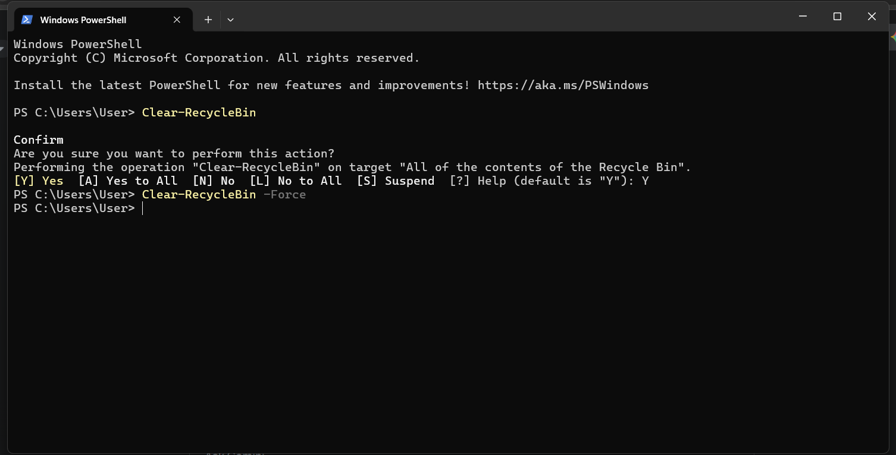
Explanation:
Figure 7: Clear-RecycleBin
Clear-RecycleBin without any parameter will ask to confirm, Clear-RecycleBin with Force parameter will not ask anything to confirm.

2.3.2. Clear-RecycleBin with force parameter
PowerShell Code
Clear-RecyleBin -force
Figure 8: Clear-RecycleBin -force

Explanation:
Clear-RecycleBin -Force is used to permanently delete all the contents of the current user's RecycleBin without prompting for confirmation. If we use Clear-RecycleBin without force parameter, it will ask for confirmation.

3. New-LocalUser
The New-LocalUser cmdlet in PowerShell creates a new local user account on a computer.

3.1 What does the command do?
It is part of the Microsoft.PowerShell.LocalAccounts module. We can create an additional user using various parameter for your computer. We must run PowerShell with Administrator privileges to use this cmdlet. (Microsoft, 2025)

3.2 Key Functionality and Parameters New-LocalUser
Parameter | Type | Description
-Name | String | Mandatory. Specifies the username for the new account.
-Password | SecureString | Specifies a password for the account. The value must be a secure string object (e.g., created with Read-Host -AsSecureString).
-NoPassword | SwitchParameter | Creates the user account without a password. You must specify either -Password or -NoPassword.
-FullName | String | Specifies the full name for the user (e.g., "John Doe").
-Description | String | Specifies a comment or description for the user account.
-Disabled | SwitchParameter | Indicates that the user account should be created in a disabled state.
-AccountExpires | DateTime | Specifies the date and time when the account will expire. Use Get-Date to create a DateTime object.
-AccountNeverExpires | SwitchParameter | Indicates that the account never expires (the default setting).
-PasswordNeverExpires | SwitchParameter | Indicates that the password never expires.
UserMayNotChangePassword | SwitchParameter | Indicates that the user is not allowed to change their own password.
(Microsoft, 2025)
Table 3: New-LocalUser Parameters

3.3 Example of New-LocalUser
The New-LocalUser cmdlet in PowerShell is used to create a new local user account on a computer running Windows.

3.3.1 Create a User Account Without a Password
This command creates a new local user named Alamgir and specifies that the account has no password (Microsoft, 2025).
PowerShell Code
New-LocalUser -Name “Alamgir" -Description "Temporary Guest Account" -NoPassword
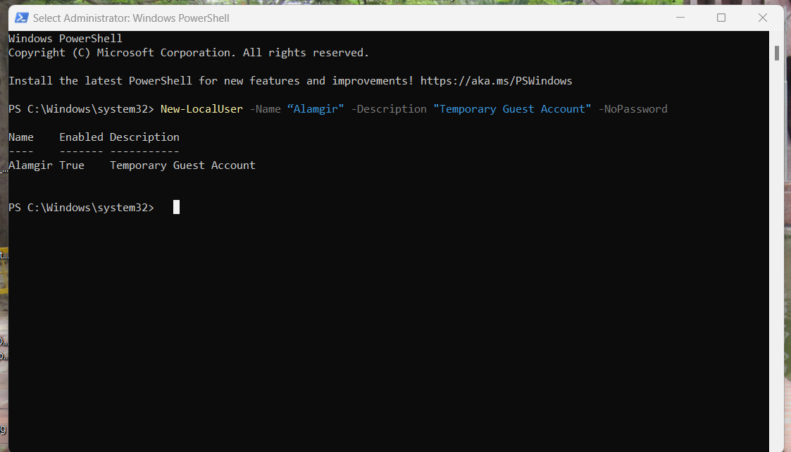
Explanation:
Figure 9: New-LocalUser cmdlet
This cmdlet creates user without any parameter or any properties. In the example, it created a local user named “Alamgir” with a description “Temporary Guest Account”.

3.3.2 Create a User Account with a expire date
To create a user with expire date, we can use $ExpireIn parameter with New-LocalUser cmdlet.
PowerShell Code
New-LocalUser -Name "Hossain" -NoPassword -AccountExpires $ExpireIn30Days
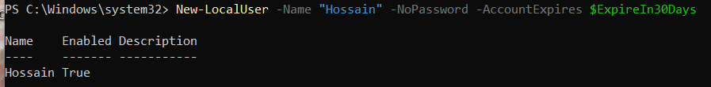
Explanation:
Figure 10: New-LocalUser with Expire Parameter
This cmdlet will create new local user without password that validity will expire in 30 days. Sometime windows administrator needs to create temporary guest users for local machine or server, new-LocalUser with expiry date parameter helps to create these kinds of users.

4. Set-LocalUser cmdlet
The Set-LocalUser cmdlet in PowerShell is used to modify the properties of an existing local user account.

4.1 What does the command do?
This includes changing the password, updating the description, setting an expiration date, or controlling password policies. It requires Administrator privileges to run.

4.2 Key Parameters of Set-LocalUser
This cmdlet identifies the target user by Name, InputObject (a LocalUser object), or SecurityIdentifier (SID).
Parameter | Type | Description
-Name | String | Mandatory (by name). Specifies the user name of the local user account to modify.
-Password | SecureString | Sets a new password for the account. The value must be a secure string (e.g., from Read-Host -AsSecureString).
-Description | String | Specifies a new comment or description for the user account.
-FullName | String | Specifies a new full name for the user.
-AccountExpires | DateTime | Specifies the new expiration date and time for the account. Use Get-Date to create a DateTime object.
-AccountNeverExpires | Boolean | Set to $True to ensure the account never expires (overrides -AccountExpires).
-PasswordNeverExpires | Boolean | Set to $True to ensure the user's password never expires.
-UserMayNotChangePassword | Boolean | Set to $True to prevent the user from changing their own password.
(Microsoft, 2025)
Table 4: Set-LocalUser cmdlet parameters

4.3 Example of Set-LocalUser cmdlet

4.3.1 Change a User's Description
This command changes the description of an existing local user named Alamgir.
PowerShell Code
Set-LocalUser -Name "Alamgir" -Description "New description: student"
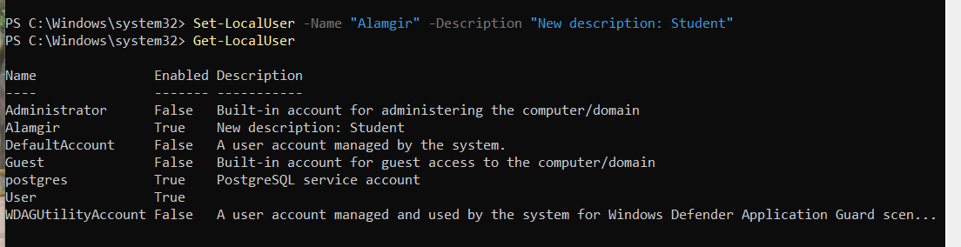
Figure 11: Set-LocalUser cmdlet
Explanation:
This will change the user description. For example, here, user new description has been changed to Student.

4.3.2 Set an Existing User's Password
PowerShell Code:
Set-LocalUser -Name "Hossain" -Password $SecurePassword
Figure 12: Set-LocalUser
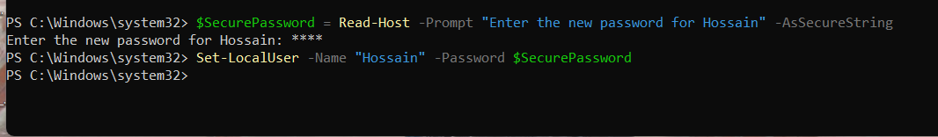
Explanation:
With this code we updated an existing user password setup. This user did have any password but now there will be a password option for this user.

CHAPTER | 02

PowerShell Script File to open three news websites in separate tabs.

1. What is PowerShell Script File?
A PS1 file is a script file used in Windows PowerShell to make work easy, timesaving and more convenient. It may contain a series of commands written in scripting language to do single or multiple task in a local or remote single or multiple computer.

2. What PowerShell Script File does
PowerShell Script File is written and execute to automate tasks and processes on a Windows system. It is used to execute same task or commend or multiple tasks or commands to multiple computer or server. For example, if a user requires to install a piece of software or update any software or setup to multiple servers or computer, PowerShell Script file is very helpful time saving tools to complete this task.

3. How to create a ps1 file:

3.1 Step 1: Open a Text Editor
Open Notepad, or any other plain text editor.

3.2 Step 2: Enter the Script Content
Paste the following code into the editor. This script uses the built-in Windows command Start-Process.

3.3 PowerShell Code for Script File
-----------------------------------------------------------------------------------------------------------------
# TodaysNews.ps1
Start-Process "msedge.exe" "https://regina.ctvnews.ca/"
Start-Process "msedge.exe" "https://www.bbc.com/"
Start-Process "msedge.exe" "https://www.cbc.ca/"
------------------------------------------------------------------------------------------------------------------

3.4 Step 3: Save the File
- Go to File > Save As.
- Navigate to a location where you want to save the script (e.g., your Desktop or Documents folder).
- In the File name field, type: TodaysNews.ps1
- In the Save as type dropdown, select All Files (*).
- Click Save.

4. How to run the PowerShell Script

4.1 Option 1: Run from PowerShell (Recommended)
- Open PowerShell (search for it in the Start Menu).
- Use the cd command to navigate to the directory where you saved the file. This example, we saved the file in C:\BIS directory. Execute the script by typing the file name preceded by.\ (dot-backslash):

PowerShell Code to run ps1 file from PowerShell.
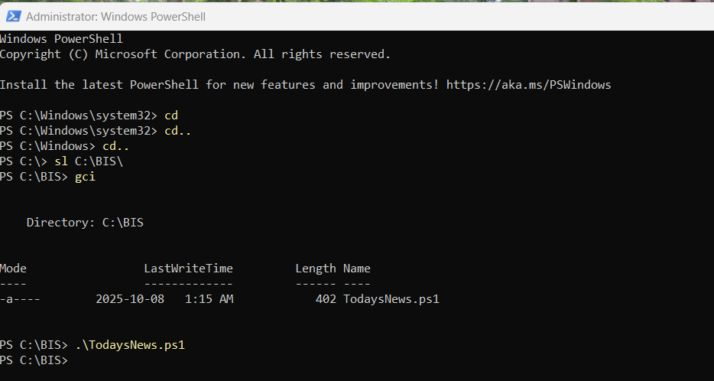
PS C:\BIS> .\TodaysNews.ps1
Figure 13: TodaysNews.ps1

4.2 Option 2: Run by Double-Clicking (Requires Setup)
By default, double-clicking a .ps1 file opens it in a text editor for security reasons. To enable double-clicking to run the script:
- Right-click the TodaysNews.ps1 file.
- Select Run with PowerShell.
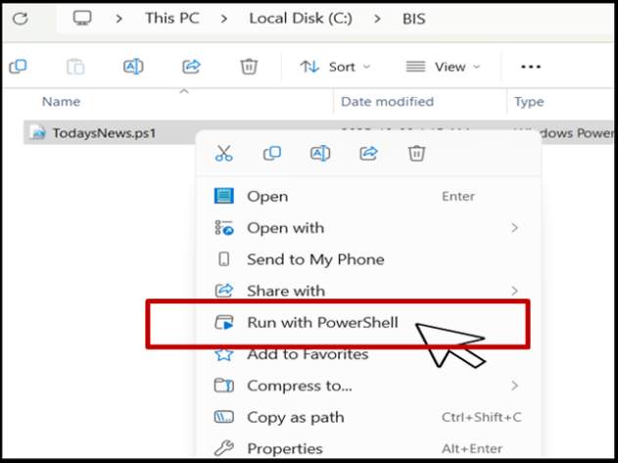
Figure 14:Run PowerShell (right-click)

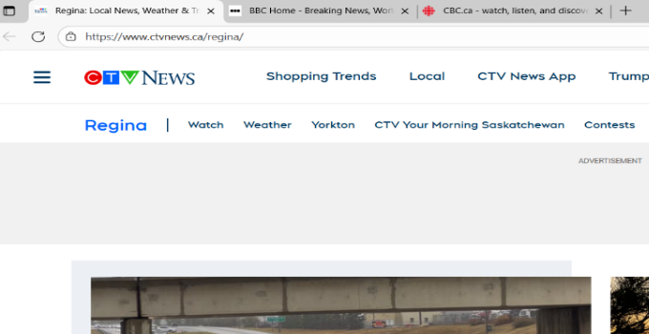
This will run the script, and Microsoft Edge will open with all three news sites loaded in separate tabs.
Figure 15: Windows with three news sites

Note:
If you find error to run this file in computer, it may happen for your PowerShell execution. You should change your PowerShell Execution Policy setup. For example, user can temporarily change PowerShell Execution Policy setup.
PowerShell Code
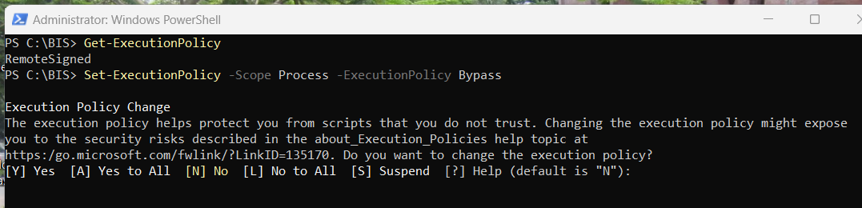
Set-ExecutionPolicy -Scope Process -ExecutionPolicy Bypass

Figure 16: Set-ExecutionPolicy

References
Microsoft. (2025). Clear-RecycleBin. Retrieved from learn.microsoft.com: https://learn.microsoft.com/en-us/powershell/module/microsoft.powershell.management/clear-recyclebin?view=powershell-7.5
Microsoft. (2025). Clear-RecycleBin. Retrieved from learn.microsoft.com: https://learn.microsoft.com/en-us/powershell/module/microsoft.powershell.management/clear-recyclebin?view=powershell-7.5
Microsoft. (2025). Clear-RecycleBin. Retrieved from learn.microsoft.com: https://learn.microsoft.com/en-us/powershell/module/microsoft.powershell.management/clear-recyclebin?view=powershell-7.5
MicroSoft. (2025). Clear-RecycleBin. Retrieved from learn.microsoft.com: https://learn.microsoft.com/en-us/powershell/module/microsoft.powershell.management/clear-recyclebin?view=powershell-7.5
Microsoft. (2025). Get-Clipboard. Retrieved from learn.microsoft.com: https://learn.microsoft.com/en-us/powershell/module/microsoft.powershell.management/get-clipboard?view=powershell-7.5
Microsoft. (2025). Get-Clipboard. Retrieved from learn.microsoft.com: https://learn.microsoft.com/en-us/powershell/module/microsoft.powershell.management/get-clipboard?view=powershell-7.5
Microsoft. (2025). New-LocalUser. Retrieved from learn.microsoft.com: https://learn.microsoft.com/en-us/powershell/module/microsoft.powershell.localaccounts/new-localuser?view=powershell-5.1
Microsoft. (2025). PowerShell. Retrieved from learn.microsoft.com: https://learn.microsoft.com/en-us/powershell/scripting/overview?view=powershell-7.5
Microsoft. (2025). Set-LocalUser. Retrieved from Learn.microsof.com: https://learn.microsoft.com/en-us/powershell/module/microsoft.powershell.localaccounts/set-localuser?view=powershell-5.1
MicroSoft. (2025). What is PowerShell. Retrieved from Microsoft Learn: https://learn.microsoft.com/en-us/powershell/scripting/overview?view=powershell-7.5
MicroSoft_WeB. (2025). PowerShell Module Browser. Regina: Microsoft.

